School of Engineering

(Far-Western University)

Mahendranagar, Kanchanpur

[Subject Code: …………]

A MINOR PROJECT PROPOSAL ON

“PARKING MANAGEMENT SYSTEM”

Submitted by: Roll no. Submitted to:

1)Suna Chaudhary 46 Er. Birendra Singh Dhami

2)Santoshi Ayer 42 Department of Engineering,FWU

3)Yashoda Badu 48

4)Ravi Bhatt 38

Date:2079/01/25

Abstract

Our project is about the “advanced parking management system”. The main purpose of C++ project on parking system is to manage the details of duration, parking fees, customers, parking slots, types. It carryon information about duration, vehicles types. The purpose of project to build an application program to reduce the manual work for managing the duration, parking fees, vehicles customers.

The drivers especially those who may need get the parking spaces may find it impossible to access it since there could be other vehicles blocking the way and yet they must hurry to book for parking spaces. This is because of using paper based which is insecure and needs self-contact to reserve for parking and it’s also time consuming, to design the parking management system will provide better efficiency in locating parking space and paying for it.

Key Words: Vehicles, parking, space

Acknowledgement

At first, we would like to express our sincere thanks to Far Western University Department of Engineering and the special thanks to our respected teacher Er. Birendra Singh Dhami for giving us the opportunity to work in a project which will be fruitful for the upcoming days.

TABLE OF CONTENTS:

ABSTRACT …………………………………………………………………………………….1

ACKNOLEDGEMENT……………………………………………………………………… 2

TABLE OF CONTENTS ……………………………………………………………………. 3

CHAPTER 1: INTRODUCTION …………………………………………………………. 4

* 1. Background …………………………………………………………………..4
  2. Problem Statement ……………………………………………………….5
  3. Objectives ……………………………………………………………………..5
  4. Applications …………………………………………………………………..6
  5. Project Features ……………………………………………………………6
  6. Feasibility Analysis ………………………………………………………..7
     1. Economic Feasibility …………………………………………….7
     2. Technical Feasibility …………………………………………….7
     3. Operational Feasibility …………………………………………7
  7. System Requirement …………………………………………………….8
     1. Software Requirement …………………………………………8
     2. Hardware Requirement ……………………………………….8

CHAPTER 2: LITERATURE REVIEW ……………………………………………………...9

2.1 Introduction ……………………………………………………………………...9

2.2 Overview of vehicles parking system …………………………………9

CHAPTER 3: METHODOLOGY …………………………………………………………...11

CHAPTER 4: EPILOGUE …………………………………………………………………..…12

4.1 Expected Output ………………………………………………………………12

4.2 Working Schedule …………………………………………………………….13

REFERENCES ……………………………………………………………………………..……..14

**CHAPTER 1: INTRODUCTION**

* 1. **Background**

every day. Parking is extremely needed since every trip with a vehicle starts and endsParking is something that almost everyone is familiar with and nearly all of us do in a parking lot. However, parking in populated areas is something irritating that may increase driver’s stress levels, affect their daily productivity, and dirty the environment. The latest survey shows that during peak hours in most large cities, the traffic generated by cars checking out parking areas takes up to 40% of the full traffic (Wang, 2011). Therefore, in these densely-populated urban areas, a traffic jam and delay is caused by parking. Another recent study also shows, in a business district of Los Angeles, vehicles looking for parking burn 47,000 gallons of gasoline and produced 730 tons of carbon dioxide, which is equivalent to 38 trips around the world (Wang, 2011). Parking management is necessarily needed to influence drivers' search time and cost looking for parking spaces, parking revenue, and traffic congestion. Parking as an industry becomes more profitable since the parking industry generates billions of dollars in annual revenue in the United States alone. In Indonesia itself, the demand for parking lots tends to increase from year to year as the number of vehicles continues to increase. In conditions like this, there will certainly be an increase in demand for parking lots which unless they are fulfilled can cause problems. Parking problems will become increasingly serious with the 2 increasing flow of urbanization, rapid growth of vehicles, and pressure from manufacturers of motorized vehicles.

**1.2 Problem Statement**

In the modern society there is an ever increasing number of vehicles. This is leading to problems such as large urban parking lots becoming inefficient, increasing difficulty to find open spaces in busy parking lots, as well as the increasing need to devote larger area of land for additional parking spaces.

* 1. **Objectives**
* To manage the details of duration, vehicles, parking slots, customers, parking fees.
* To minimize the effects of on street parking open road safety and congestion.
  1. **APPLICATIONS**

There are several advantages of employing a car park system for urban planners, business owners and vehicle drivers. They are offer convenience for vehicle users and efficient usage of space for urban based companies. Automated car park system save time, money, space and simplify often tedious task of parking.

* 1. **Project Features**
* Automated access control system
* Parking management software
* Statistical reporting software
* Parking Guidance System
* Parking reserving barriers
* Security analysis
* Automated ticketing systems
* Real time vehicle counting

* 1. **Feasibility Analysis**
     1. **Economic Feasibility**

Economic feasibility of a car rental management system project. A system can be developed technically and that will be used if installed must still be a good investment for the organization. It does not require any addition hardware or software.

* + 1. **Technical Feasibility**

Technical feasibility of car rental management system project. The technical issue usually raised during the feasibility stage of investigation. It provides the technical guarantee of accuracy, reliability and security.

* + 1. **Operating Feasibility**

Operational feasibility car rental management system project proposed projects are beneficial only if they can be turned out into information system. The project is operationally feasible in a sense that this is done in a computer. So, data are more secure than before, reduces risk of loss of data and update in automated manner reduces the error occurring chances and this software does not require any other technical person to operate it as a person with very less computer do as fine.

* 1. **System Requirement**
     1. **Software Requirement**

Automatic parking Assist (APA) activated through the infotainment system. This will be the only way to turn APA on.

**1.7.2 Hardware Requirement**

The Human Machine Interface (HMI) is the infotainment system, which is an 8-inch touch screen in the vehicle. This will display APA’s state, prompt and receive inputs from the driver, and allow driver to abort the system at any time.

**CHAPTER 2: LITERATURE REVIEW**

**2.1 Introduction**

This chapter is the literature review of parking system in public places using the university campus covenant University as case study. It describes the features of the existing car parking systems together with the major and general types of car parking system and how they operate. Also, problems in existing system would be identified and solutions to implement would discussed in this chapter.

**2.2 Overview of Vehicles Parking System**

Car Parking system is a system that is used to help prevent congestion of cars in an allocated spot. Over the years, car parking systems and the accompanying technologies have increased and diversified. It was developed in the early 20th century in response to the need for storage of vehicles.

Some system can be implemented to help track how many cars pass through the gate and the time spent in the parking by each, and then bill the car when existing. This parking system increases the number of cars that can be parked in the car park. It provides more parking spaces since the cars are parked in an organized way. Use of a car parking system requires less area of land than when there is none being used. This system helps in enabling safe parking of cars as compared to the rugged way of parking vehicles.

**Chapter 3: METHODOLOGY**

For a vehicle parking management system, using the concept of C++ programming language, we created different classes using the concept of inheritance to know the details of duration, customer, parking fees, parking slots, types of vehicles and details of each vehicle. We created one class to identify the type of vehicle and created another class vehicle as the child class of the vehicle type class. We also used the concept of switch statement, file handling, pointer and array. We also created class for delete the details of vehicles if necessary. 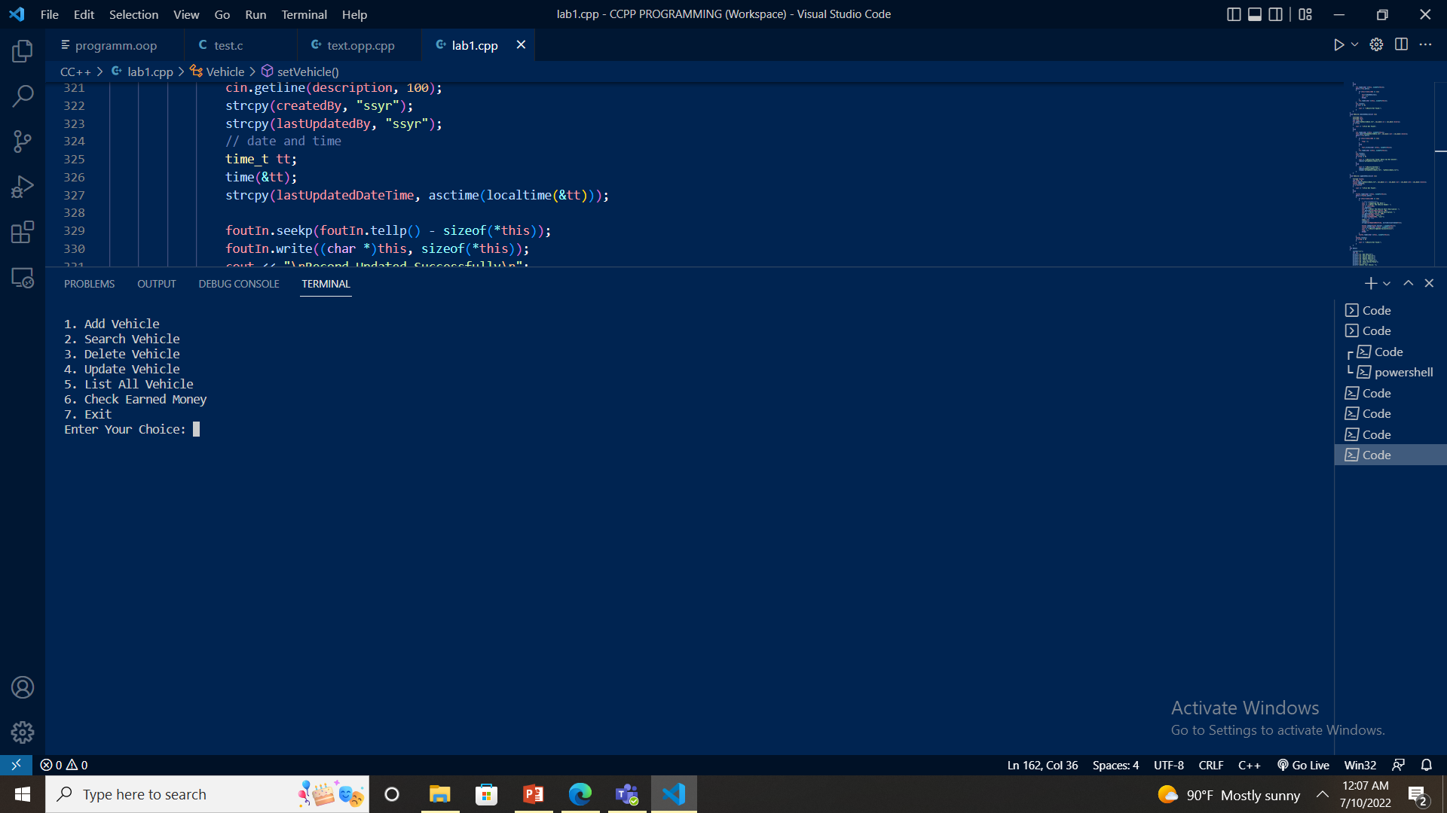

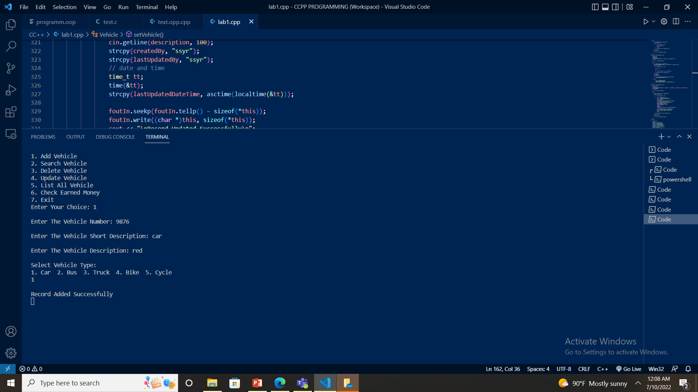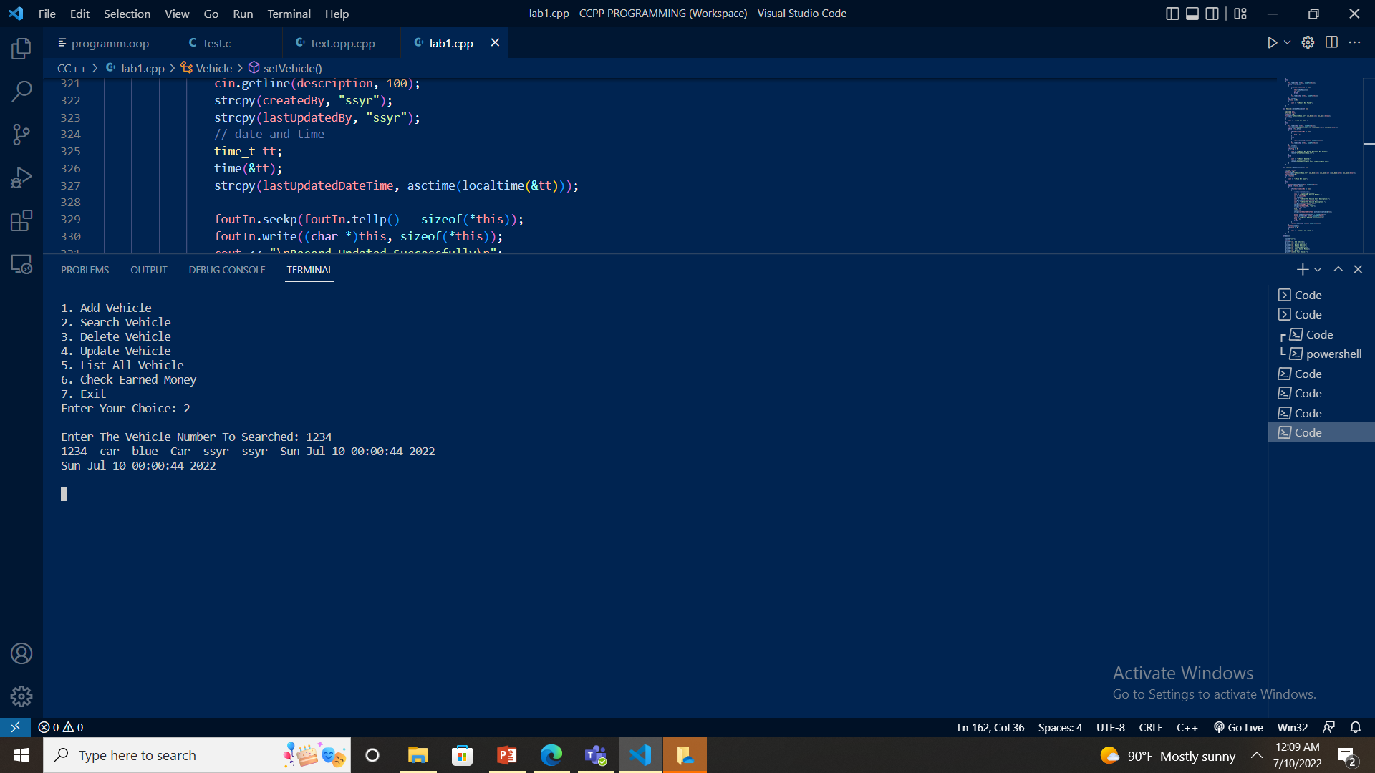

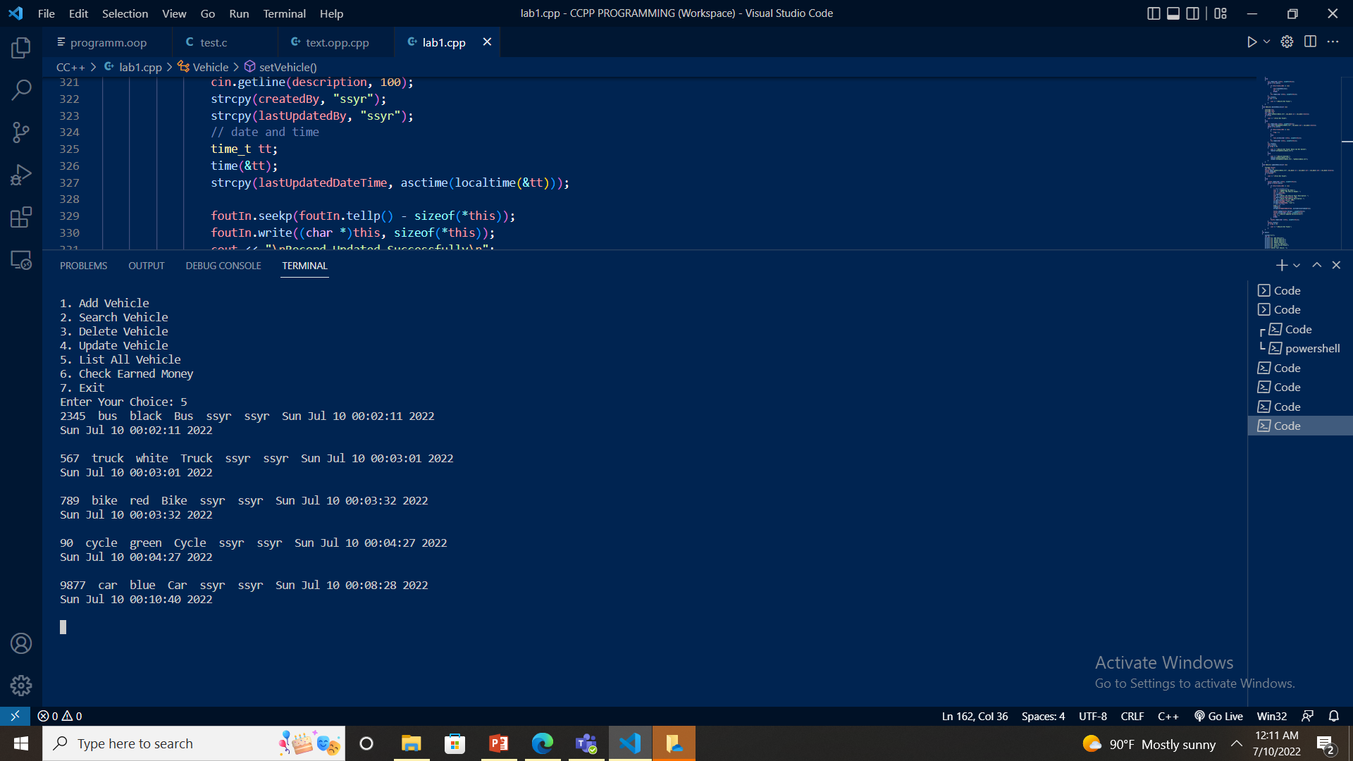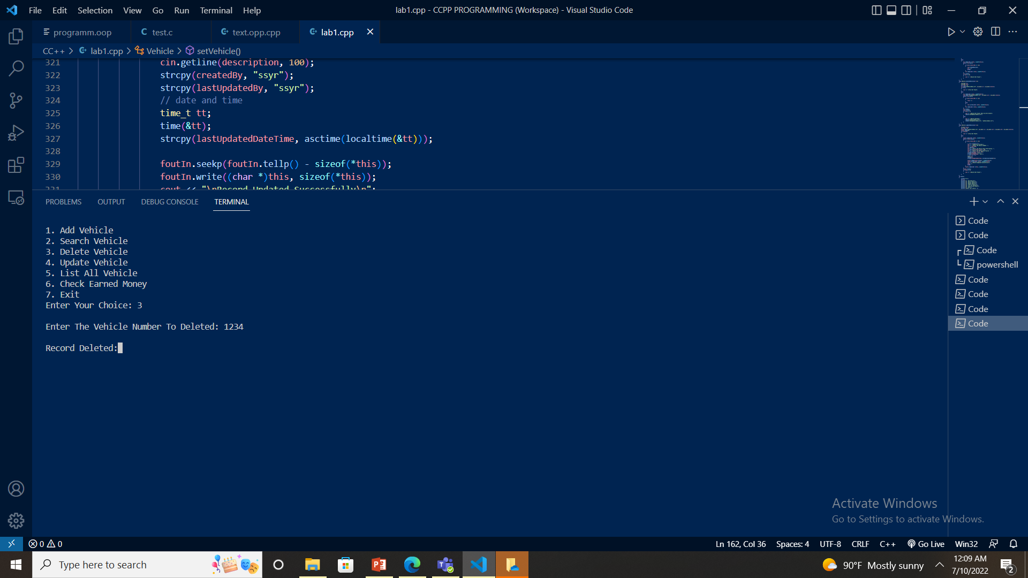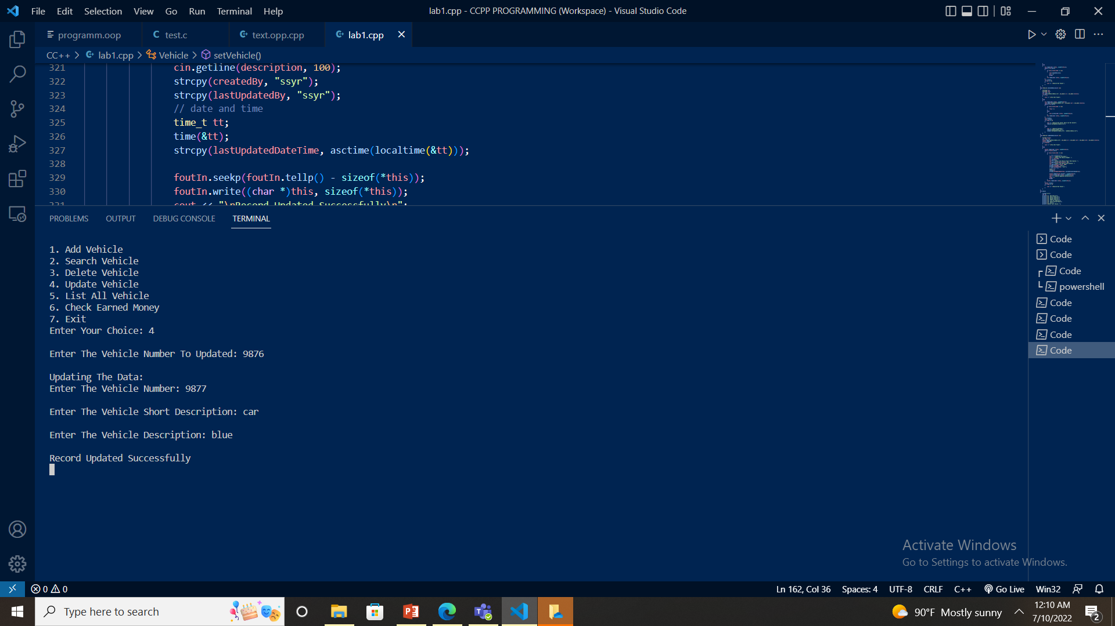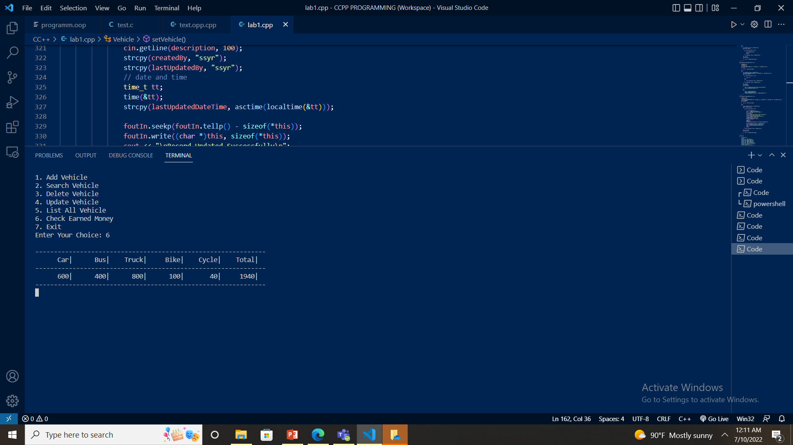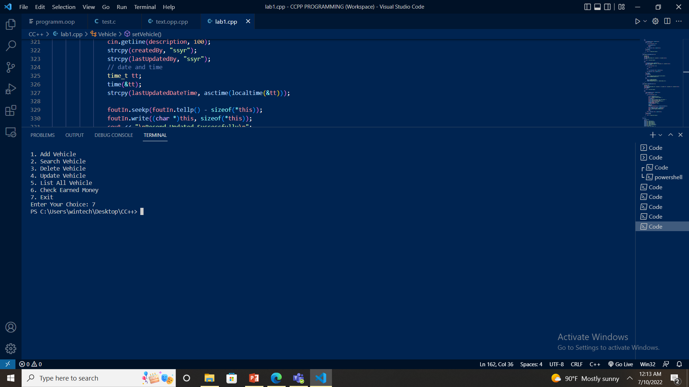

**CHAPTER 4: EPILOGUE**

**4.1 Output**



**4.2 Work Schedule**

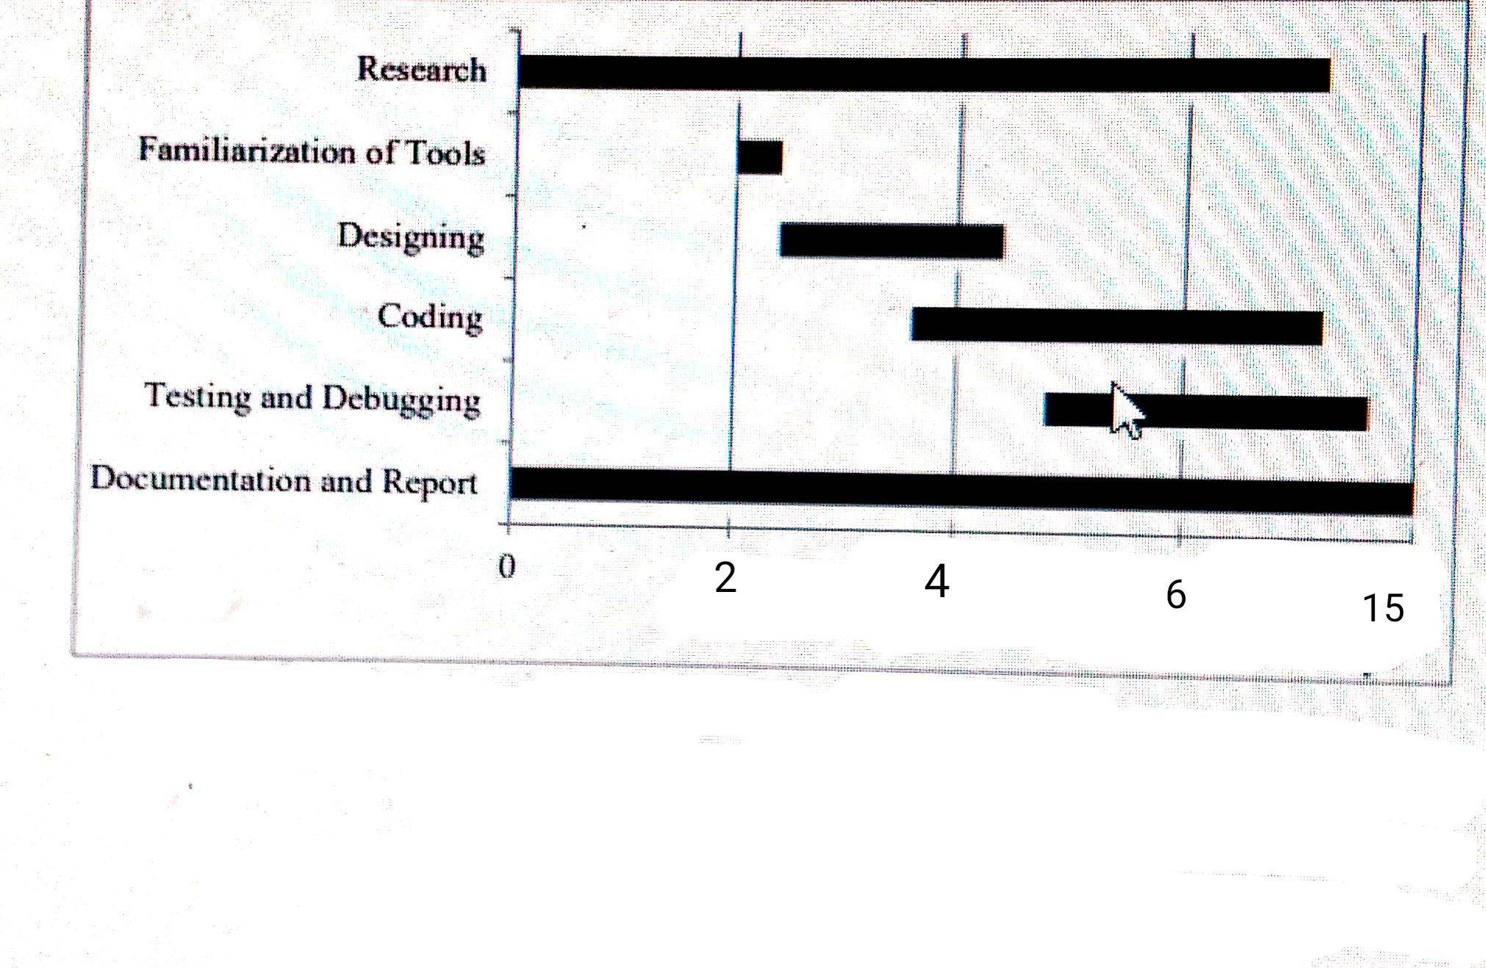

**REFERENCES**

* M.Naor and Shamir, ‘Visual cryptography’, Eurocrypt 1994, Lecture Notes in Computer Science.
* Z Zhou, G. R. Arce and G. Di Crescenzo, ‘Halftone visualcryptography’
* M. Nakajima and Y. Yamaguchi, “Extended visual cryptography for natural image

1. Top of Form